When are you eligible for unemployment benefit in Latvia if you were last employed in another EU Member State?

- People who were last employed in another EU Member State are only eligible for unemployment benefit in Latvia in exceptional cases where they maintain close ties with the country of residence while working in another Member State, e.g. they reside permanently in Latvia. The place of residence is determined on the basis of factors such as the duration and continuity of stay in the respective Member States; the nature and stability of the activity pursued and the duration of any employment contract; marital status and family ties; the pursuit of unpaid activities; the housing situation, especially its permanence; and the Member State of residence for tax purposes.

NB: During your last period of employment, you must have resided in the Member State where unemployment benefit is claimed, and not the Member State whose legislation applies to you (the country of employment).

- Generally, the following categories of workers are entitled to receive unemployment benefit in Latvia:
  - frontier workers (persons pursuing an employed or self-employed activity in a Member State to which they return, as a rule, daily or at least once a week);
  - seasonal workers;
  - mariners;
  - people who work in two or more Member States;
  - people subject to the agreement referred to in Article 16 of Regulation (EC) No 883/2004.
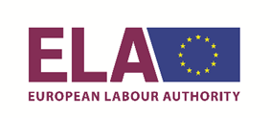
VSAA izmanto Eiropas Darba iestādes atbalstu
tulkojumu nodrošināšanā

